3.73: a) The acceleration is given as g at an angle of 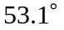 to the horizontal. This is a 3-4-5 triangle, and thus, 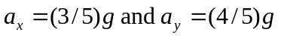 during the "boost" phase of the flight. Hence this portion of the flight is a straight line at an angle of to the horizontal. After time T, the rocket is in free flight, the acceleration is 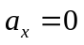 and 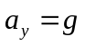, and the familiar equations of projectile motion apply. During this coasting phase of the flight, the trajectory is the familiar parabola.
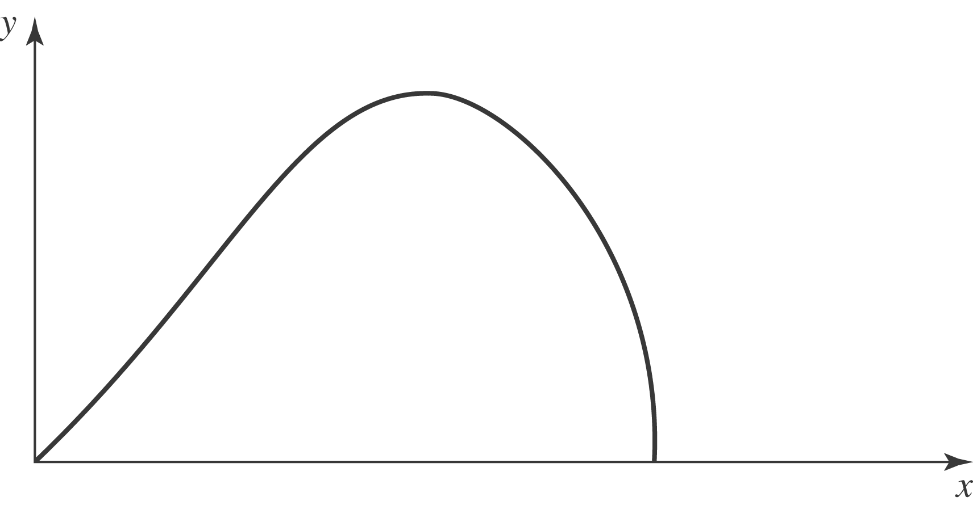

b) During the boost phase, the velocities are: 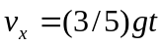 and 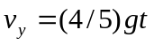, both straight lines. After 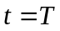, the velocities are 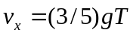, a horizontal line, and 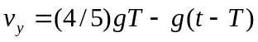, a negatively sloping line which crosses the axis at the time of the maximum height.

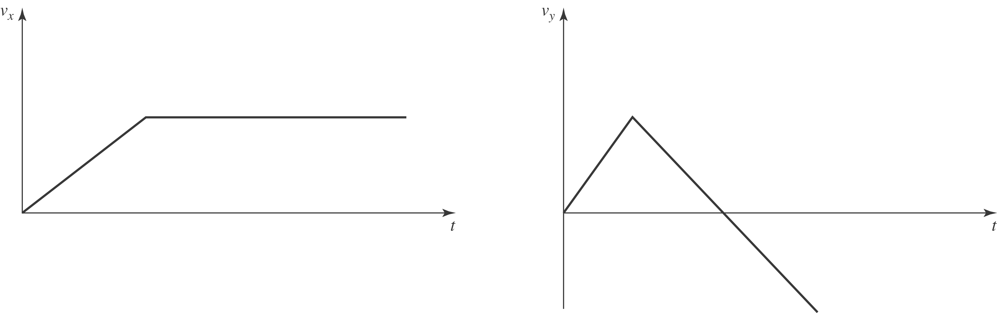

c) To find the maximum height of the rocket, set 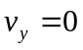, and solve for t, where 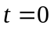 when the engines are cut off, use this time in the familiar equation for y. Thus, using 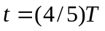 and Combining terms, 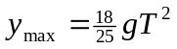.
d) To find the total horizontal distance, break the problem into three parts: The boost phase, the rise to maximum, and the fall back to earth. The fall time back to earth can be found from the answer to part (c), 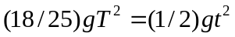, or 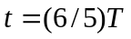. Then, multiplying these times and the velocity, 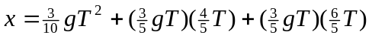, or 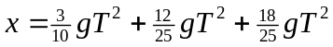. Combining terms gives 

